



Implement Bellman-Ford algorithms
LAB MANUAL

Disclaimer: The content is curated from online/offline resources and used for educational purpose only
Implement Bellman-Ford algorithms on graphs with negative edge weights

Objective:
To implement the Bellman-Ford algorithm for graphs with negative edge weights and analyze its ability to detect negative weight cycles.
Problem Statement:
Implement the Bellman-Ford algorithm to compute the shortest paths from a single source node in a graph that may contain negative edge weights. The algorithm should also detect if a negative weight cycle exists in the graph.
Equipment Required:
- Python installed with Jupyter Notebook
- No external libraries needed (uses built-in data structures)

Prerequisites:
- Knowledge of graph representations (adjacency list)
- Understanding of shortest path problems
- Awareness of negative weights and cycle detection
Procedure:
Step 1: Define the Bellman-Ford Algorithm
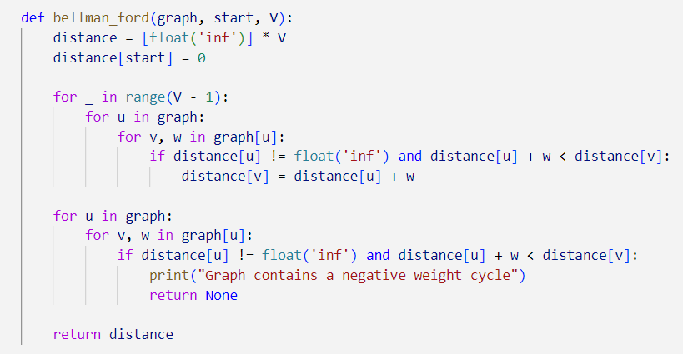

Step 2: Create a Sample Graph with Negative Weights

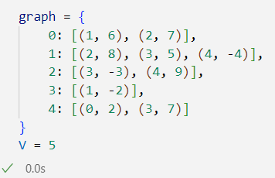

Step 3: Execute the Bellman-Ford Algorithm and Display Output
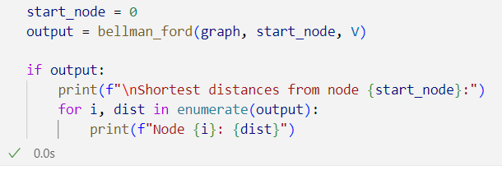

Output:
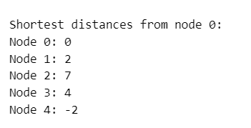
Conclusion
The Bellman-Ford algorithm successfully computes shortest paths from a single source even when the graph contains negative edge weights. It also detects negative weight cycles, which is crucial in real-world scenarios such as:
- Banking systems: to prevent interest-based debt loops
- Routing algorithms: to avoid illogical loops that reduce cost infinitely
- Game development: to detect invalid moves in state transition graphs
Unlike Dijkstra’s algorithm, Bellman-Ford works correctly with negative weights and provides a reliable solution for more generalized graph problems.

